H2 - COM slowdown during nose sweeps
Result: H2 NOT supported. Center-of-mass (COM) speed is HIGHER, not lower, during nose sweeps - on both the primary R-based sweep set and the non-circular numerator-only (body-frame) headline test.

1. Goal and hypotheses
Goal: test whether the mouse's body center of mass (COM) slows around the times of nose sweeps, as would be expected if a sweep is a discrete, quasi-stationary sampling behaviour.
H2: COM speed decreases around nose sweeps (during-window speed < trial baseline).
H0: during-window COM speed = baseline COM speed.
Decision rule (pre-registered): Accept H2 iff v_com is significantly lower during sweeps FOR THE NUMERATOR-ONLY (body-frame) sweep set - the non-circular test - because the R-based detector defines R = v_nose / v_com and could make a COM dip definitional.

2. Methods
Data accessor and shared library: reactions_common (reactions_common/1.0); headless matplotlib (Agg). Random seed 1234 throughout (bootstraps and any resampling).
Kinematics: nose = head keypoint, COM = body keypoint, both sampled on the head clock. Speeds v_nose and v_com are Savitzky-Golay velocity estimates (px/s).
Sweep detectors (two, run in parallel):
- R-detector: sweeps from the ratio R = v_nose / v_com (primary set).
- Numerator-only body-frame detector (D7): sweeps from nose kinematics in the body frame, containing NO v_com term - this is the non-circular set on which H2 acceptance rests.
During window: [-0.25, 0.25] s around each sweep peak (D13).
Baseline: trial median v_com. A secondary +-1 s window-edge baseline variant is also reported.
Test: paired Wilcoxon (during < baseline), one-sided in the H2-predicted direction. Unit of analysis = trial; pooled Loc1-6, n = 105 trials (n_trials_pooled = 105).

3. Results
Direction first, then significance; the headline is the null.

3.1 Primary R-based sweep set
During-window COM speed is HIGHER than baseline: median during = 25.96 px/s vs median baseline (trial median v_com) = 17.25 px/s. The paired Wilcoxon for during < baseline is non-significant (statistic = 4880.0, p = ~1.0); the predicted slowdown is absent - COM is faster during sweeps.
Secondary +-1 s window-edge baseline: median during = 25.96 px/s vs median edge-baseline = 31.99 px/s. Here during < edge-baseline is statistically significant (statistic = 143.0, p = 1.61e-17), but this reflects that the +-1 s window edges sit on the fastest part of the peri-sweep trace (see F1B) rather than a true slowdown relative to typical trial speed; against the trial-median baseline there is no slowdown.

3.2 Mandatory circularity control
Because R = v_nose / v_com, a COM dip in the R-set could be definitional. Two controls address this.
(i) Driver split (pooled): of 21841 pooled sweeps, 14432 are nose-driven (v_nose > trial median) and 18576 are COM-dropout (v_com < trial median); 11178 satisfy both. A large share of sweeps are nose-driven with the COM still moving, i.e. not COM dropouts.
(ii) Numerator-only (body-frame) headline test (D7, non-circular): median during = 41.98 px/s vs median baseline = 17.25 px/s; paired Wilcoxon during < baseline statistic = 5553.0, p = ~1.0. This independent detector - which contains no v_com - ALSO shows no slowdown; COM speed is in fact HIGHER during sweeps.
slowdown_survives_numerator_only = False. Because the non-circular test also shows no slowdown, the absent slowdown is not merely definitional - it is a genuine absence. Sweeps occur during active locomotion, not during quasi-stationary pauses.

3.3 Figures
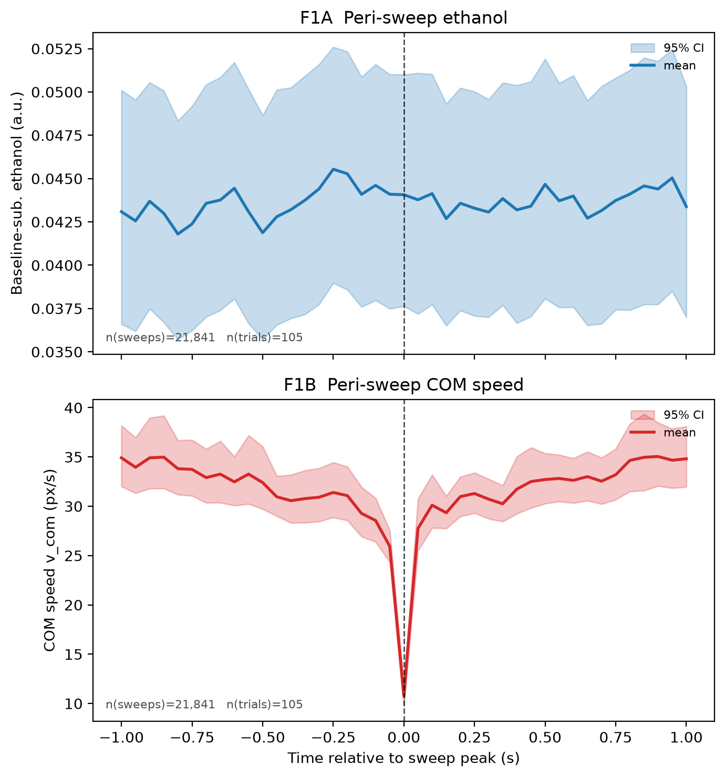
Figure F1. Peri-sweep averages, pooled Loc1-6 (n = 21841 sweeps, 105 trials). Top (F1A): baseline-subtracted ethanol. Bottom (F1B): peri-sweep COM speed v_com (px/s) vs time relative to sweep peak. F1B is broadly flat/high across the peri-window (~30-35 px/s); the single-frame notch at t = 0 is the instantaneous peak-alignment artefact, not a sustained slowdown. Across the H2 during window [-0.25, 0.25] s the COM remains at typical or above-typical speeds - consistent with the Wilcoxon result.
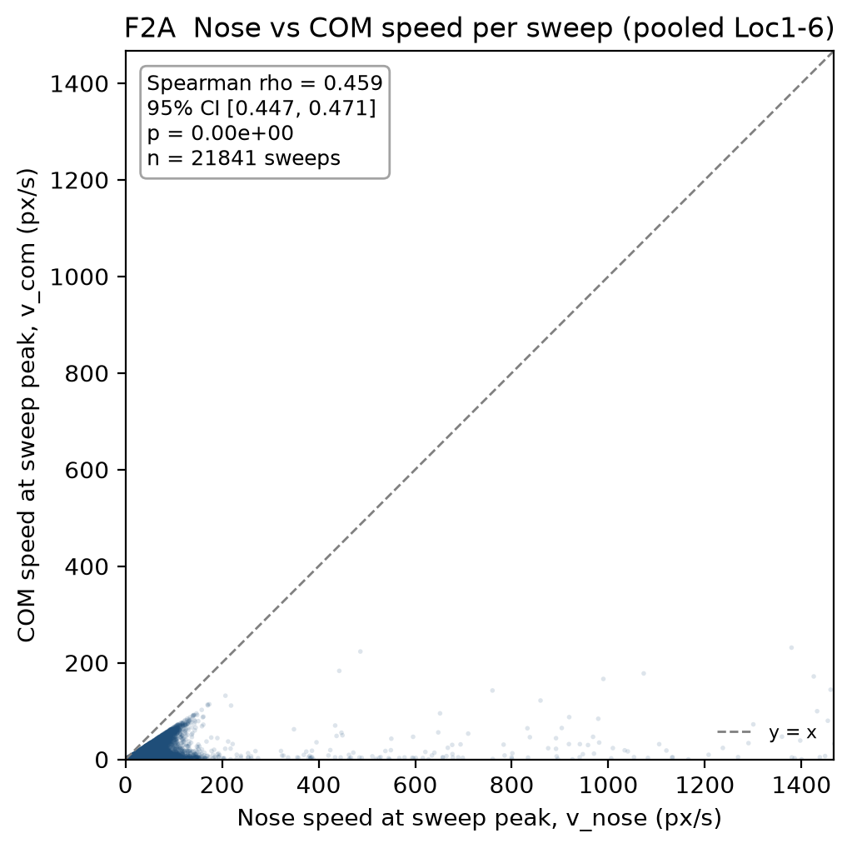
Figure F2A. Nose speed vs COM speed at sweep peak, one point per pooled sweep (n = 21841). x = v_nose@peak, y = v_com@peak (px/s). Spearman rho = 0.459235, 95% CI [0.447428, 0.470722], p = 0.000000e+00 (describes the plotted cloud; seed 1234). The strong positive association shows that fast nose sweeps coincide with a fast-moving COM - the opposite of the H2 prediction that sweeps accompany COM slowdown. The dashed line is y = x.

4. Caveats
R circularity: addressed. Because R = v_nose / v_com, the primary R-set result is potentially definitional; H2 is therefore headlined on the numerator-only body-frame detector (D7), which contains no v_com. That non-circular test reproduces the null (COM higher during sweeps), so the conclusion does not depend on the R definition.
Single cohort; distances in pixels (not physical units), so absolute speeds are camera/scale-specific; the qualitative direction (COM faster, not slower, during sweeps) is scale-invariant.
The single-frame t = 0 notch in F1B is a peak-alignment artefact of averaging at the detected peak; it does not constitute a sustained slowdown and does not change the during-window medians.

5. Reproducibility
Interpreter (headless Agg):
"C:/Projects/Repos/Agentic Research/Research Setup/vras/Scripts/python.exe" code/_build_F2A.py
"C:/Projects/Repos/Agentic Research/Research Setup/vras/Scripts/python.exe" code/_build_H2_report.py
Result files:
data/stats.json (H2 block - all injected numbers)
data/sweeps.h5 (/sweeps columns v_nose, v_com, in_pooled - F2A scatter)
reports/figures/F1_peri_sweep_odor_and_com.png (embedded; panel F1B = v_com)
reports/figures/F2A_nose_vs_com.{png,pdf,txt}
Seed 1234; reactions_common/1.0; pooled Loc1-6 n = 105 trials.

